AWS NETWORK FIREWALL DEMO LAB

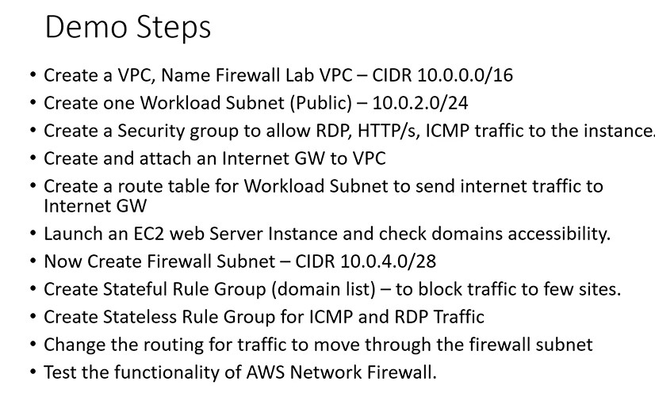

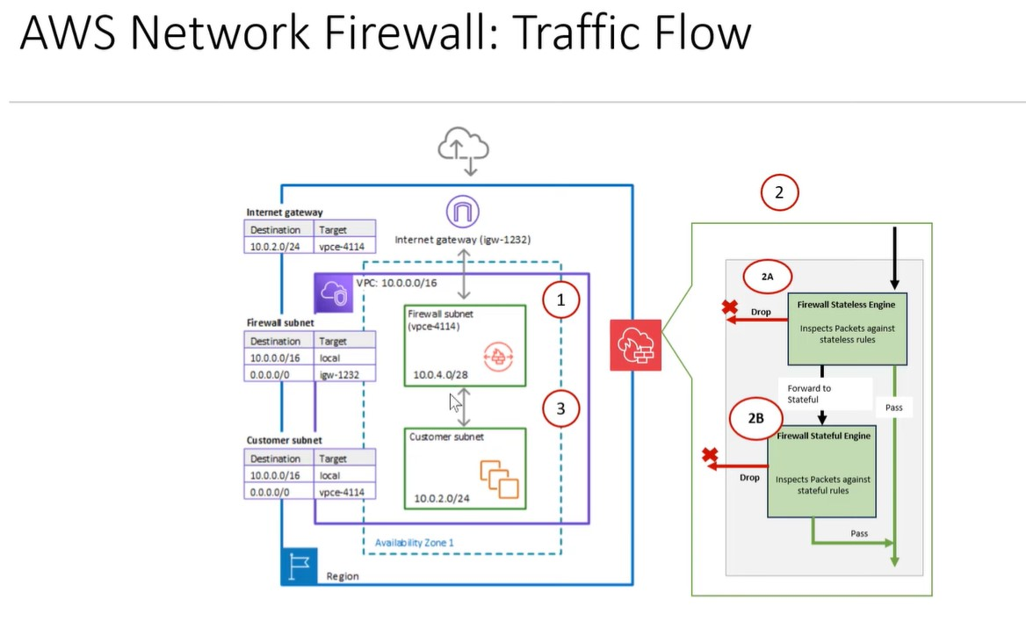

**STEP 1:- Created a VPC with firewall and public subnet.**

**Created 2 Route table attach each with subnet.**

**Created Internet Gateway and attach to the VPC.**

**Launch an EC2 Instance in the Public Subnet.**

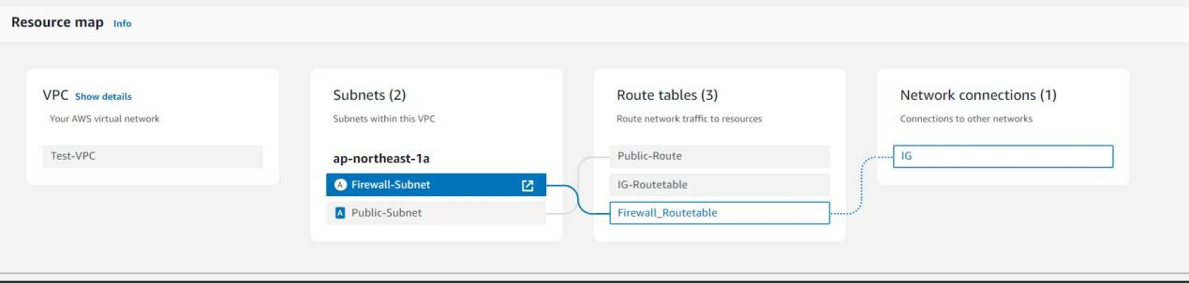

**STEP 2 :- Created Rule Group in Network Firewall Section.**

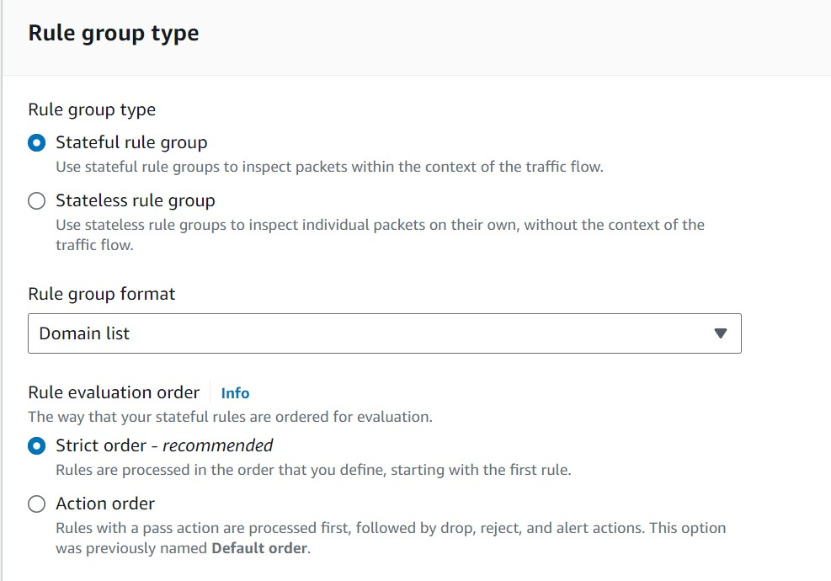

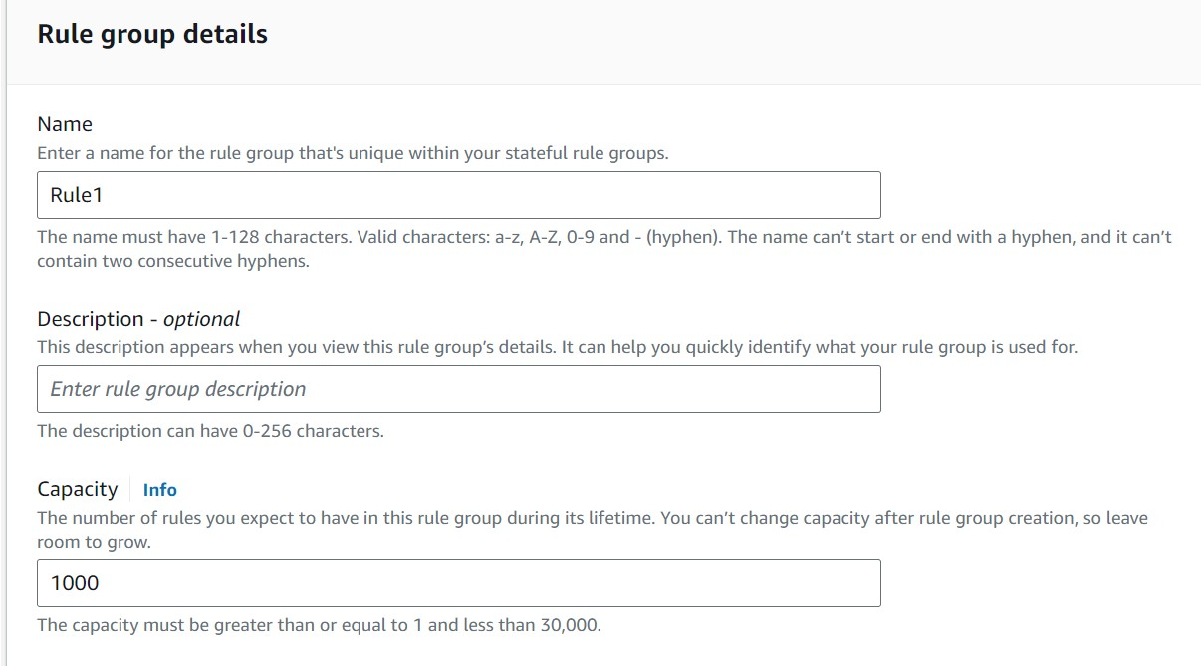

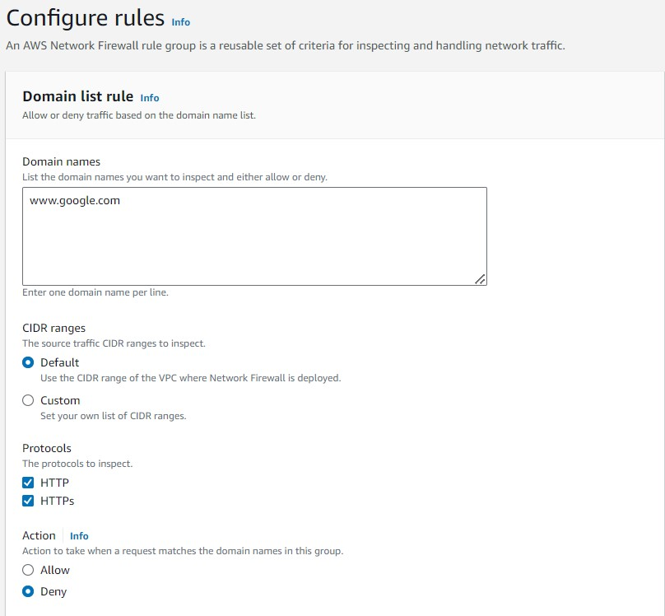

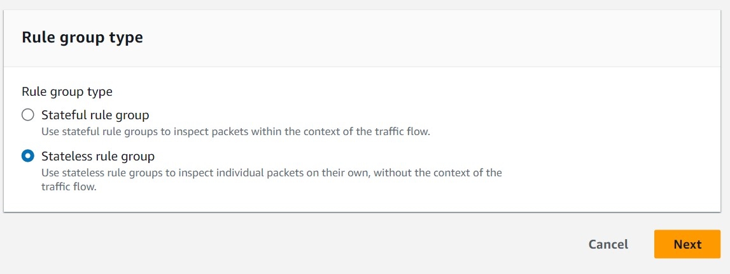

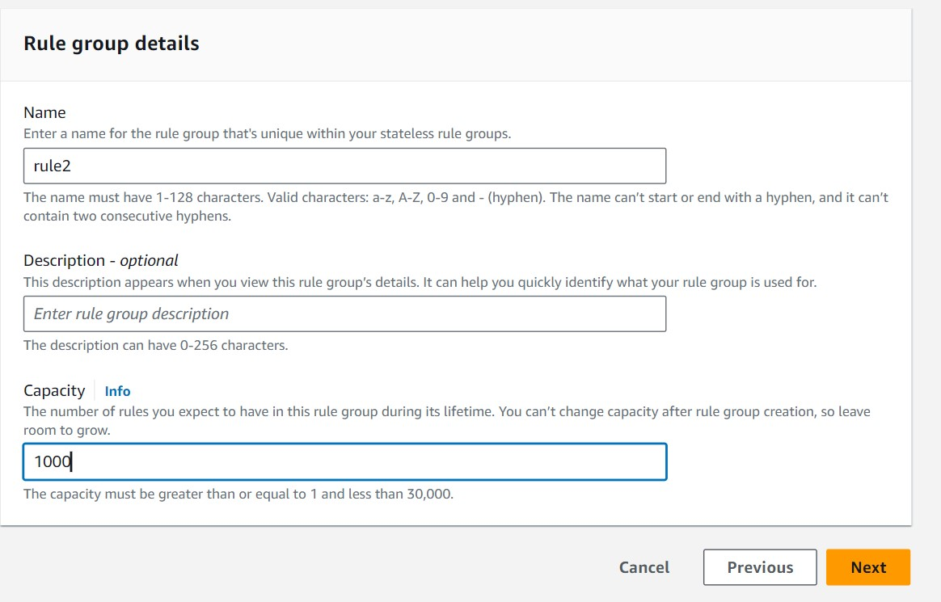

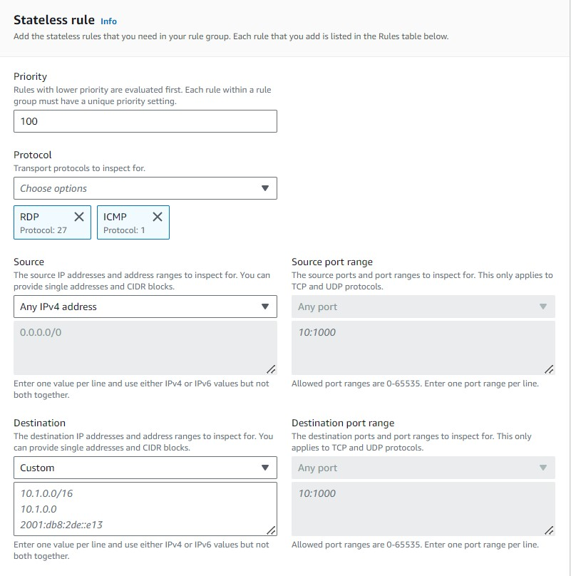

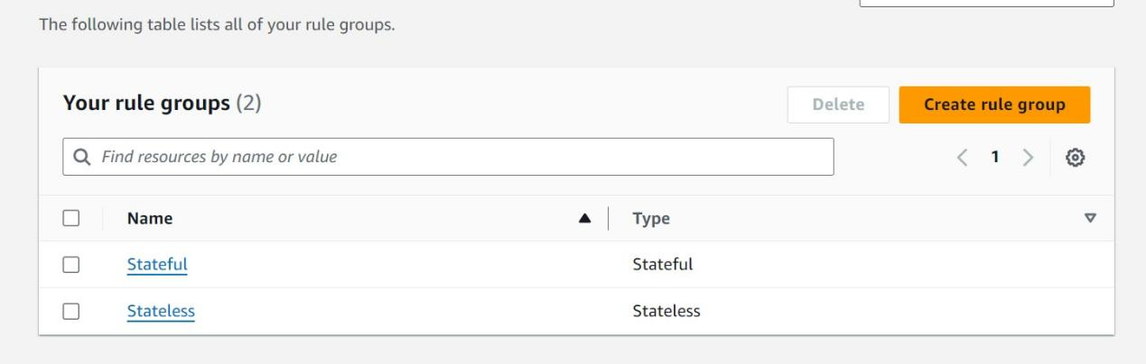

**STEP 3 :- Created Firewall Policy in the Network Firewall Section.**

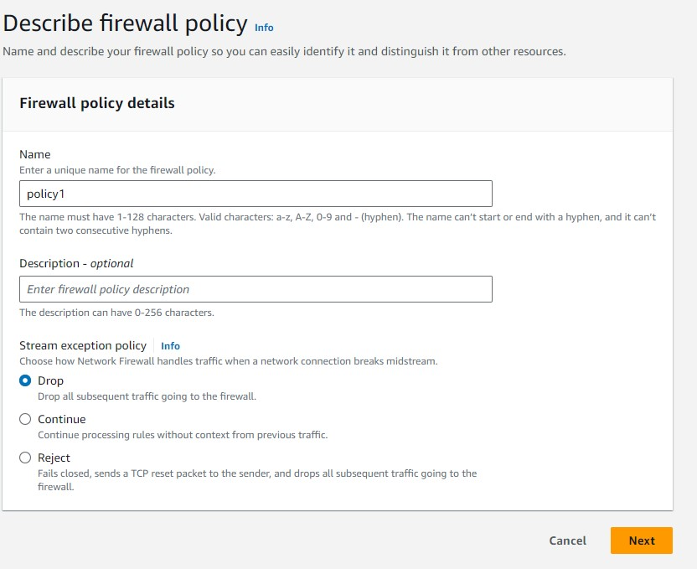

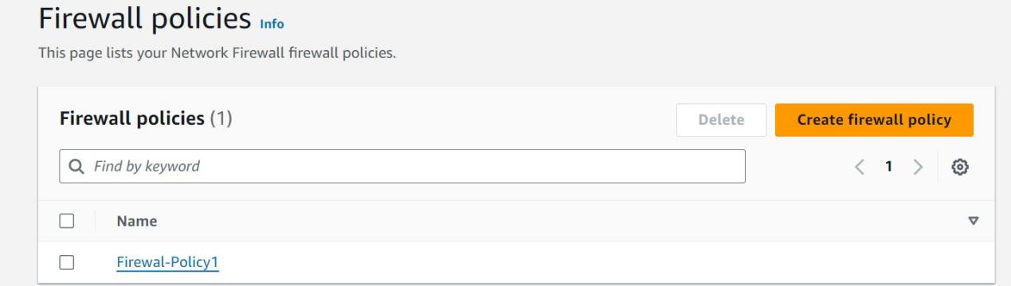

**STEP 4 :- Created Network Firewall and attached the Policy to it.**

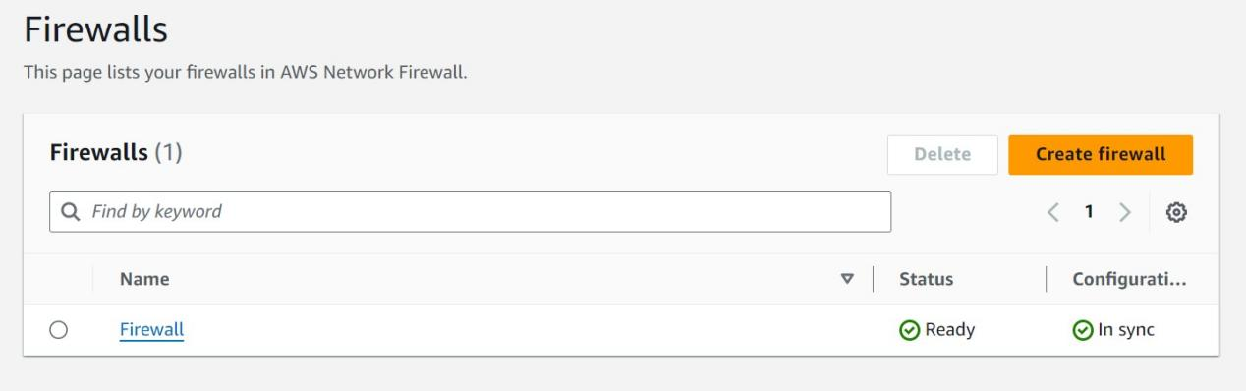

**STEP 5 :- Enable logging in the Netowork Firewall and Save it in S3**

**Bucket**

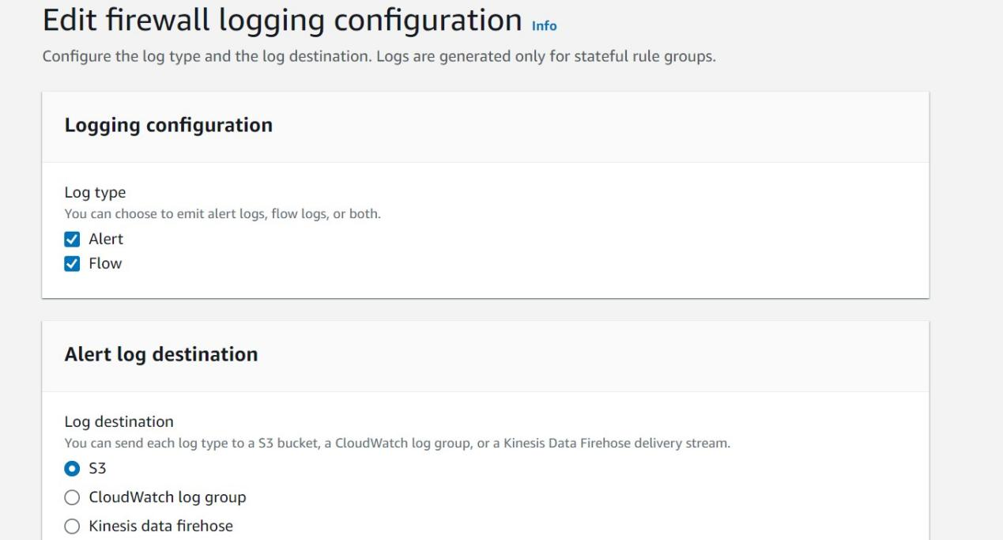

**STEP 6 :- Check on the Instance for the website’s, which we blocked is accessible or not.**

